Multiple choice section

|  |  |  |  |  |  |  |  |  |  |  |
| --- | --- | --- | --- | --- | --- | --- | --- | --- | --- | --- |
| Question | 1 | 2 | 3 | 4 | 5 | 6 | 7 | 8 | 9 | 10 |
| Answer | A | B | C | A | A | A | D | D | B | C |

Question 1 [1.1]

A

10 + 2x = 14



Question 2 [1.1]

B

2(a – 1) = 3(a + 1)



Question 3 [1.2]

C

4x – 2y = 8

4x – 8 = 2y

y = 2x – 4

∴ gradient = 2

Question 4 [1.2]

A

Lines parallel to the y-axis (vertical lines) have an undefined gradient.

Question 5 [1.3]

A

y = mx + b

y = x + 2

Question 6 [1.4]

A

The line with equation y = -2x + 1 has the gradient of -2.

The line with equation 2x + y = -2 can be expressed as y = -2x – 2 where both lines have the same gradient of -2. These lines are parallel.

Question 7 [1.4]

D

The line with equation y = 2x + 4 has a gradient of 2. A line that is perpendicular to this line has a gradient of  as .

Question 8 [1.5]

D



Question 9 [1.5]

B

 < 1

2 – 5x < 8

-5x < 6

x > -1.2

So x = -1.5 is not a solution.

Question 10 [1.6]

C

Substitute y = 2x into y + x = 15:

2x + x = 15

3x = 15

x = 5

Substitute x = 5 into y = 2x:

y = 2 × 5 = 10

x = 5, y = 10

Multiple-choice total marks: 10

Short answer section

Question 11 10 marks

(a) A linear relationship is described by a *linear equation*.

(b) Linear equations can be solved by applying *inverse operations* to both sides of the equation.

(c) The *gradient* of a line is a measure of its steepness, which can be evaluated by evaluating the fraction *rise over run*.

(d) The general equation of a straight line is y = mx + b where m is the gradient of the line and b is the *y-intercept* of the line.

(e) Lines that are *parallel* have the same gradients.

(f) Lines that are *perpendicular* meet each other at an angle of .

(g) A linear equation has *one* solution and a linear *inequality* has a range of solutions according to the inequality.

Question 12 4 marks [1.3, 1.4]

Answers may vary.

Lines which are parallel to the line y = x have gradients of 1 and lines which are perpendicular to that line have gradients of -1. The equations and graphs of the lines need to have these gradients and intercept the y-axis at the position consistent with each equation.

Question 13 3 marks [1.1]



Question 14 4 marks [1.1]

3(3x – 2) = 2(2x + 2)

9x – 6 = 4x + 4

9x = 4x + 4 + 6

9x = 4x + 10

5x = 10

x = 2

Question 15 2 marks [1.2]



Question 16 2 marks [1.2]

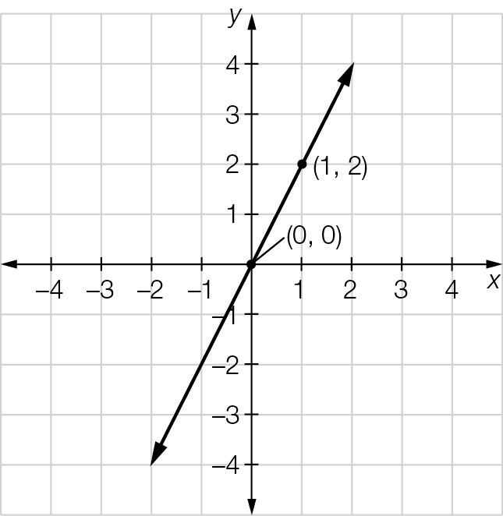



Question 17 2 marks [1.3]

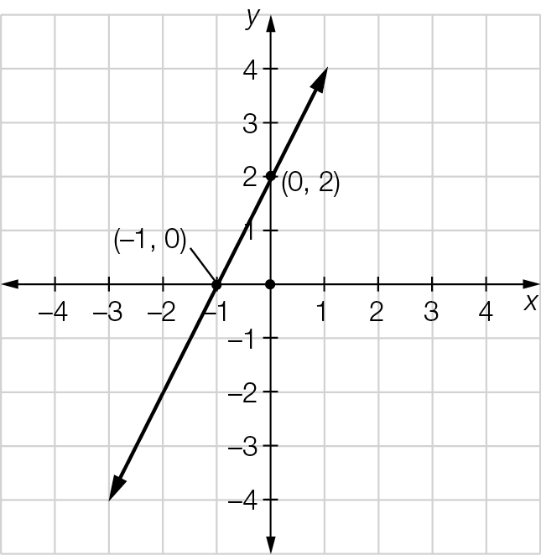 y = 2x + 2

Question 18 4 marks [1.4]

(a) The equation y – 2x = 5 can be expressed as y = 2x + 5. As the lines y = 2x + 2 and y = 2x + 5 have the same gradients then they are parallel.

(b) The gradient of the line y = x + 3 is 1, and the equation y = -x + 2 has a gradient of -1. The product of their gradients is -1 (as 1 × -1 = -1), so the lines are perpendicular.

Question 19 4 marks [1.5]

(a) 2x ≥ 16  
x ≥ 8

(b) 5x – 3 < 7  
5x < 10  
x < 2

Question 20 4 marks [1.5]

(a) 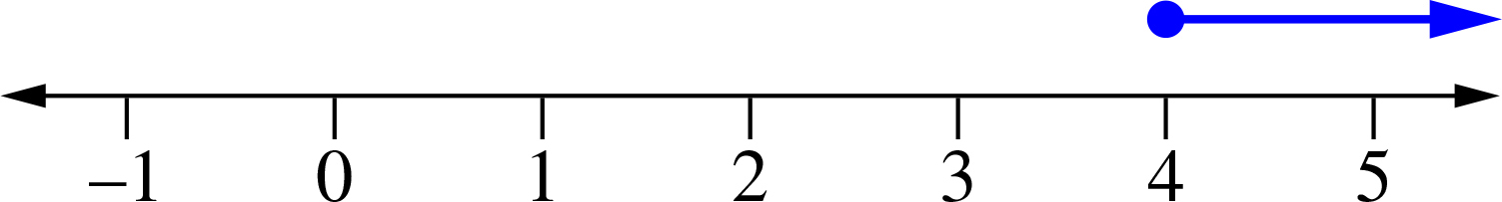

(b) 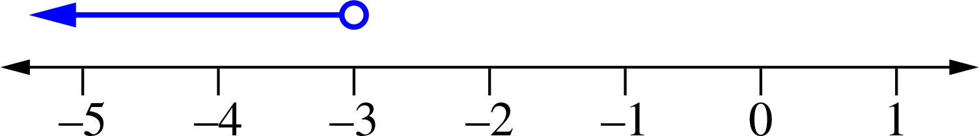

Question 21 4 marks [1.6]



Question 22 4 marks [1.6]

x – 2y = 14

3x + 2y = 2

4x = 16

x = 4

4 – 2y = 14

-2y = 10

y = -5

x = 4, y = -5

Short answer total:_________/47

Extended answer section

Question 23 4 marks [1.1]

2x + 1 + 2(x + 3) = 19

2x + 1 + 2x + 6 = 19

4x + 7 = 19

4x = 12

x = 3

x + 3 = 6

2x + 1 = 7

The dimensions are: two sides of 6 cm and one side of 7 cm.

Question 24 5 marks [1.5]

Let a and b be the cost in cents of each apple and banana, respectively.

2a + 3b = 80 [1]

a + 5b = 75 [2] × 2

2a + 10b = 150 [2]

Subtract [2]– [1]:

7b = 70, so b = 10, hence a = 25.

Each apple cost 25 cents and each banana cost 10 cents.

Question 25 4 marks [1.6]

(a) 10b ≤ 200 where b is the number of buns.

(b) 10b ≤ 200

10b ≤ 200

b ≤ 20  
The baker can make up to 20 more buns.

Question 26 10 marks [1.2, 1.3, 1.4]

(a)

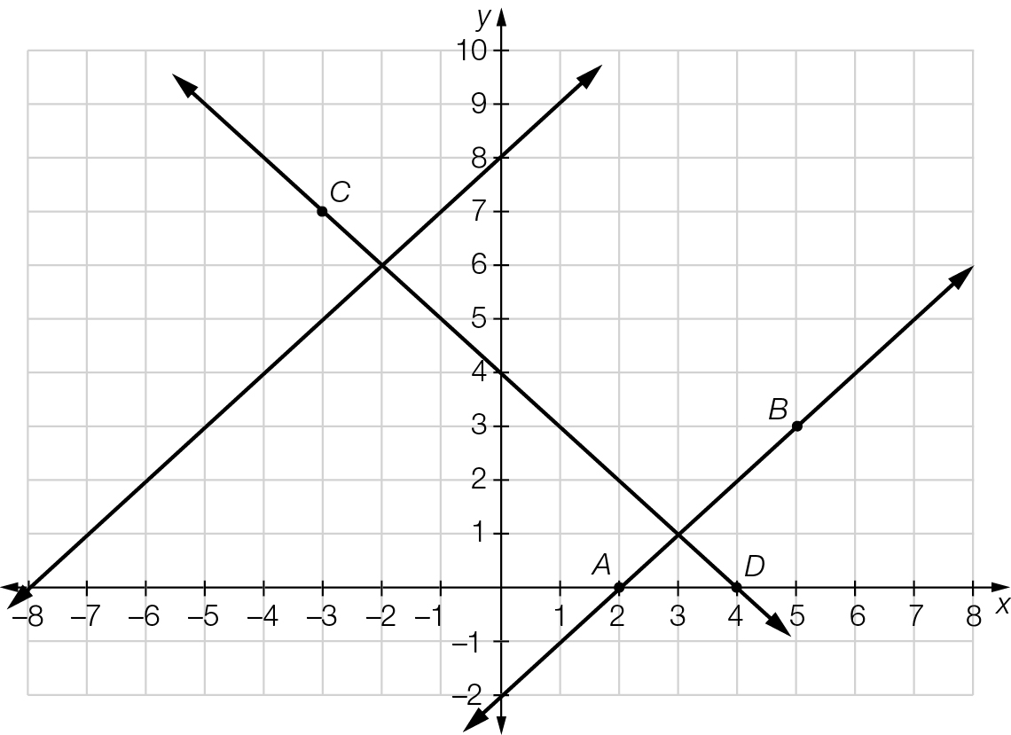

(b) (i) Equation of the line AB is y = x – 2

(ii) The gradient of both lines is 1, so they are parallel.

(c) (i) Equation of the line CD is y = -x + 4

(ii) The product of the gradient of the lines is -1 (as 1 × -1 = -1), so they are perpendicular.

Extended answer total:______/23

TOTAL test results: _____ / 80